Deliverable#2:

**Ibtisam Shahzad (22i-1201)**

**Haider Zia (22i-1196)**

**Ibrahim Asim (22i-1330)**

**Company : Smartsphere**

Outline:

**Part A-Software Requirements Specification (SRS) for Event Management System; 2**

1. Introduction 2

1.1 Purpose 2

1.2 Scope 2

1.3 Definitions, Acronyms, and Abbreviations 2

2. System Functional Requirements 3

3. System Non-Functional Requirements 3

3.1 Product Requirements 3

3.2 Organizational Requirements 3

3.3 External Requirements 3

4. Use Case Diagram 4

5. User Stories 5

7. Class Diagram 10

8. Conclusion 11

**Part B-Product Backlog for Event Management System 11**

**Introduction 11**

**Product Backlog Items 11**

Backlog Prioritization Strategy 12

**Part C-Sprint 1 Backlog (Initial Development Focus) 13**

Sprint 2 Backlog (Next Development Focus) 13

**Part E- Trello Board: 14**

Backlog: 14

Sprint 1: 16

Sprint 2: 18

**D-Github: 19**

# 

# 

# 

# 

# 

# 

# Part A-Software Requirements Specification (SRS) for Event Management System;

## **1. Introduction**

### **1.1 Purpose**

The purpose of this project is to develop a streamlined and efficient event management system tailored specifically for NASCON events. The system simplifies the process of registering, enrolling, and organizing various events, such as Olympiads, providing a robust platform for both participants and organizers.

### **1.2 Scope**

The project focuses on developing an event management system exclusively for NASCON, covering all major events including technical and non-technical competitions such as Sports. The system supports registration for participants, event enrollment, and offers organizers a comprehensive tool for managing event schedules, participants, and results. This system also addresses communication between organizers and participants.

Previous systems have lacked the unified platform needed to manage the diverse range of events held by NASCON. The project integrates key features like real-time updates, notifications, and user-friendly dashboards.

The system will support three types of users:

* **Admin**: Responsible for managing users and overseeing event operations.
* **Organizer**: Creates and manages events.
* **Participant**: Registers for and attends events.

### **1.3 Definitions, Acronyms, and Abbreviations**

* **EMS**: Event Management System
* **User**: Any individual using the system (Admin, Organizer, Participant)
* **SRS**: Software Requirements Specification
* **Use Case**: A specific system function describing user interaction

## 

## **2. System Functional Requirements**

1. **User Authentication**: Users must be able to register, log in, and update their profiles.
2. **Event Management**: Users shall create, modify, filter, and remove events.
3. **Event Enrollment**: Users shall enroll in and cancel event enrollment.
4. **Notifications & Announcements**: Users shall receive notifications and announcements related to events.
5. **Reports & Feedback**: Users shall generate reports and submit/view feedback.

## **3. System Non-Functional Requirements**

### **3.1 Product Requirements**

* The system must be available 99.9% of the time.
* The interface should be responsive and work across multiple devices.
* The system should support at least 1000 concurrent users.
* All user actions must be logged for auditing purposes.

### **3.2 Organizational Requirements**

* The system should support role-based access (Admin, Organizer, Participant).
* It should integrate with third-party calendar applications.
* Users should be able to export event reports in PDF format.

### **3.3 External Requirements**

* Compliance with data privacy policies.
* Secure storage of user data using encryption.
* Integration with email services for notifications.

## 

## 

## **4. Use Case Diagram**

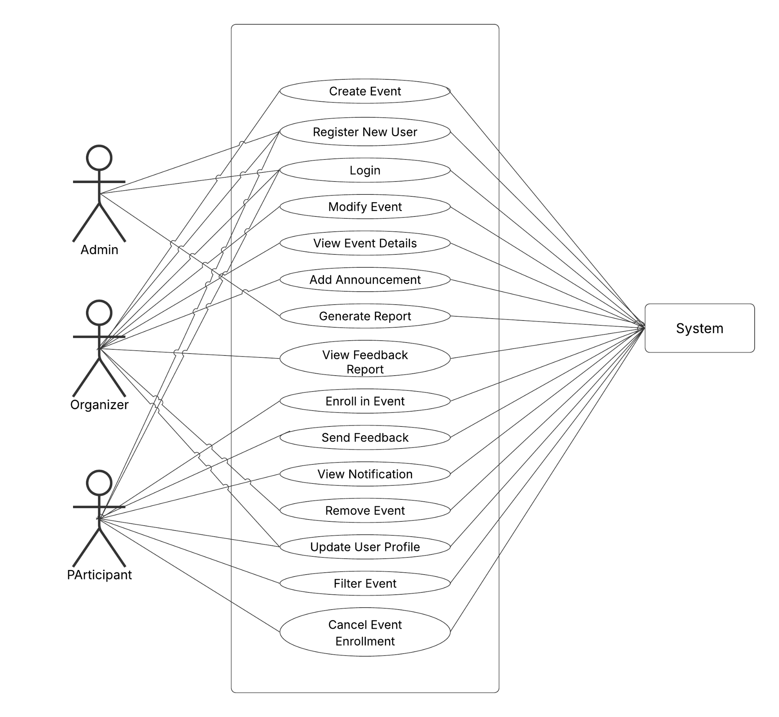

**List of Use Cases:**

1. Create Event
2. Register New User
3. Login
4. Modify Event
5. View Event Details
6. Add Announcement
7. Generate Report
8. View Feedback Report
9. Enroll in Event
10. Send Feedback
11. View Notification
12. Remove Event
13. Update User Profile
14. Filter Event
15. Cancel Event Enrollment

## **5. User Stories**

1. **As a user, I want to register an account so that I can access the system.**
   * **Pre-condition**: User must provide valid credentials.
   * **Post-condition**: User account is created.
2. **As a user, I want to log in so that I can access my dashboard.**
   * **Pre-condition**: User must enter correct credentials.
   * **Post-condition**: User is authenticated and redirected to the dashboard.
3. **As an organizer, I want to create an event so that participants can register for it.**
   * **Pre-condition**: Organizer must be logged in.
   * **Post-condition**: Event is created and visible to users.
4. **As an organizer, I want to modify an event so that I can update its details.**
   * **Pre-condition**: Organizer must have created the event.
   * **Post-condition**: Event details are updated.
5. **As an organizer, I want to remove an event so that it is no longer available.**
   * **Pre-condition**: The event must exist in the system.
   * **Post-condition**: The event is deleted.
6. **As a participant, I want to enroll in an event so that I can attend it.**
   * **Pre-condition**: User must be logged in.
   * **Post-condition**: Enrollment is confirmed.
7. **As a participant, I want to cancel my enrollment in an event so that I can withdraw from attending.**
   * **Pre-condition**: User must be enrolled in the event.
   * **Post-condition**: Enrollment is canceled.
8. **As an admin, I want to generate reports so that I can analyze event participation.**
   * **Pre-condition**: Admin must have access to event data.
   * **Post-condition**: A report is generated and available for review.
9. **As a user, I want to send feedback so that I can share my experience about an event.**
   * **Pre-condition**: The user must have attended the event.
   * **Post-condition**: Feedback is submitted and stored in the system.
10. **As a user, I want to view notifications so that I stay informed about event updates.**
    * **Pre-condition**: The user must be logged in.
    * **Post-condition**: The notification list is displayed.
11. **As a user, I want to update my profile so that my information is accurate.**

* **Pre-condition**: The user must be logged in.
* **Post-condition**: User profile information is updated.

1. **As a user, I want to filter events so that I can find relevant events based on my preferences.**

* **Pre-condition**: Events must exist in the system.
* **Post-condition**: The system displays filtered events according to the selected criteria.

1. **As an organizer, I want to add announcements so that participants receive important event updates.**

* **Pre-condition**: The user must have organizer privileges.
* **Post-condition**: Announcement is published and visible to participants.

1. **As a user, I want to view feedback reports so that I can see event reviews and ratings.**

* **Pre-condition**: The user must be logged in.
* **Post-condition**: The feedback report is displayed.

1. **As a participant, I want to cancel my event enrollment so that I can opt out if needed.**

* **Pre-condition**: The user must be enrolled in an event.
* **Post-condition**: Enrollment is canceled and the participant is removed from the list.

**6. Sequence Diagrams**

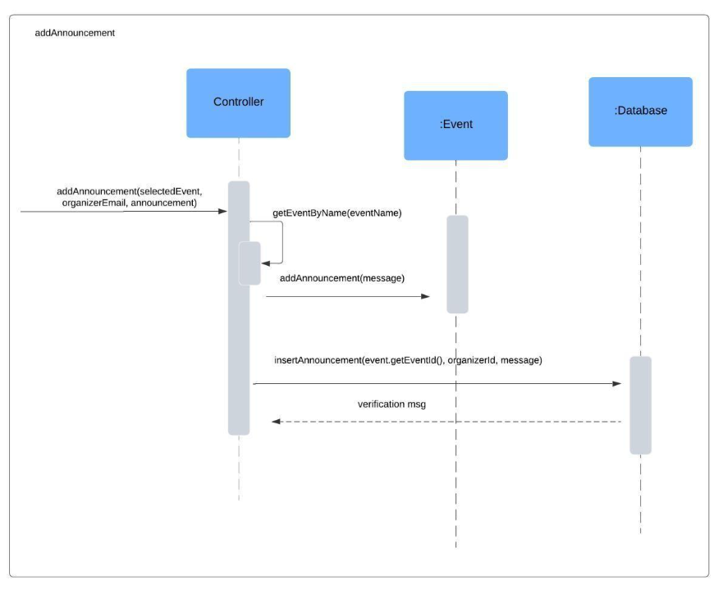

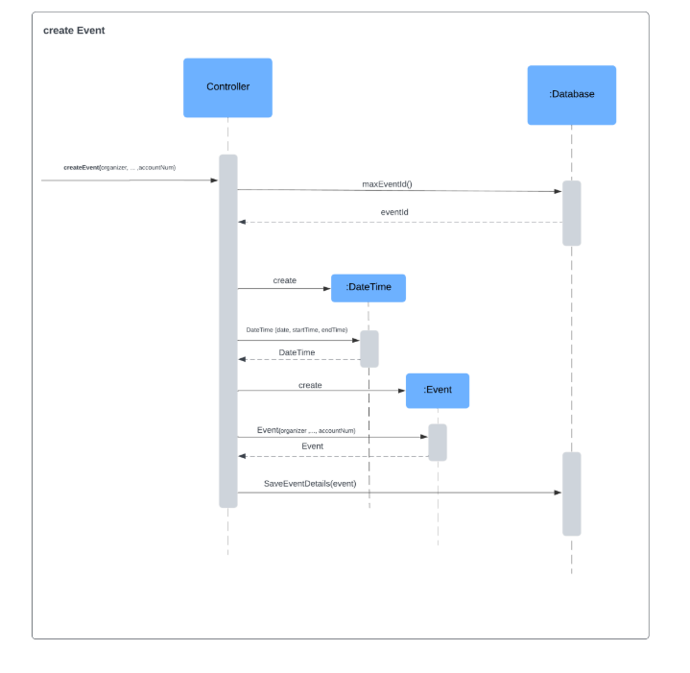

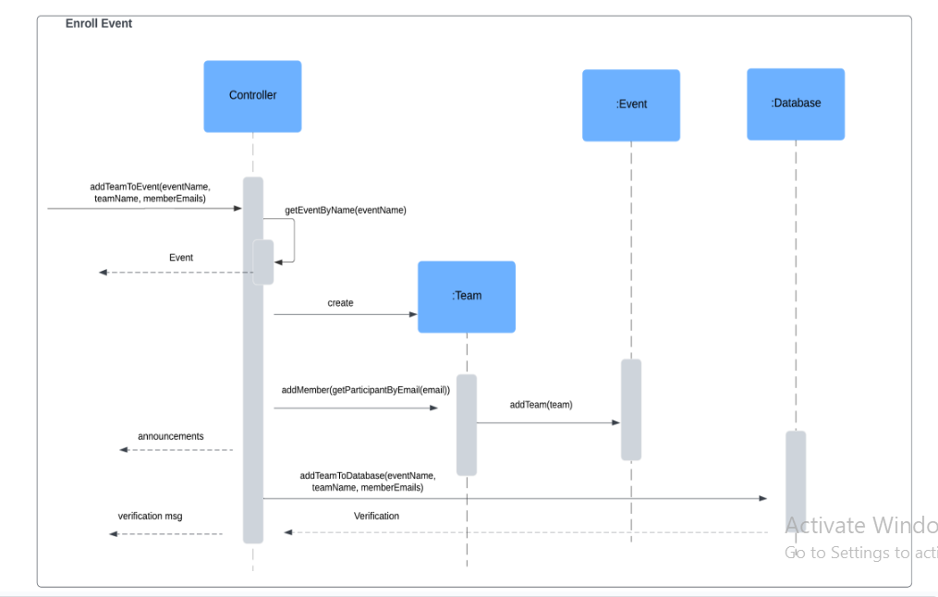

## 

## 

## 

## 

## 

## 

## **7. Class Diagram**



## 

## 

## **8. Conclusion**

The Event Management System (EMS) aims to simplify the process of organizing and attending events by offering a structured, user-friendly platform. By ensuring seamless event management, user authentication, notifications, and feedback integration, the EMS enhances the overall experience for organizers, participants, and administrators alike. This document serves as a comprehensive guide for the design and implementation of the system, ensuring clarity and alignment with stakeholder requirements.

# Part B-Product Backlog for Event Management System

## Introduction

The product backlog is a prioritized list of system features and user stories that need to be implemented in the Event Management System. Each item is categorized based on priority: **High**, **Medium**, or **Low**. High-priority items are essential for core functionality, while medium and low-priority items enhance the system but are not immediately critical.

## Product Backlog Items

| **ID** | **User Story** | **Priority** |
| --- | --- | --- |
| **US-01** | As a user, I want to register an account so that I can access the system. | **High** |
| **US-02** | As a user, I want to log in so that I can access my dashboard. | **High** |
| **US-03** | As an organizer, I want to create an event so that participants can register for it. | **High** |
| **US-04** | As an organizer, I want to modify an event so that I can update its details. | **Medium** |
| **US-05** | As an organizer, I want to remove an event so that it is no longer available. | **Medium** |
| **US-06** | As a participant, I want to enroll in an event so that I can attend it. | **High** |
| **US-07** | As a participant, I want to cancel my enrollment in an event so that I can withdraw from attending. | **Medium** |
| **US-08** | As a user, I want to send feedback so that I can share my experience about an event. | **High** |
| **US-09** | As a user, I want to send feedback so that I can share my experience about an event. | **Medium** |
| **US-10** | As a user, I want to view notifications so that I stay informed about event updates. | **High** |
| **US-11** | As a user, I want to update my profile so that my information is accurate. | **Medium** |
| **US-12** | As a user, I want to filter events so that I can find relevant events based on my preferences. | **Low** |
| **US-13** | As an organizer, I want to add announcements so that participants receive important event updates. | **Medium** |
| **US-14** | As a user, I want to view feedback reports so that I can see event reviews and ratings. | **Medium** |
| **US-15** | As a participant, I want to cancel my event enrollment so that I can opt out if needed. | **Low** |

# 

## **Backlog Prioritization Strategy**

The priority levels are determined based on:

1. **High Priority** – Essential features for system operation, such as user authentication, event creation, enrollment, and notifications.
2. **Medium Priority** – Important features that enhance user experience, such as event modification, feedback submission, and report generation.
3. **Low Priority** – Additional features that improve usability but are not immediately critical, such as event filtering and profile updates.

This backlog will be refined and updated in each sprint based on changing requirements and feedback.

# **Part C-Sprint 1 Backlog (Initial Development Focus)**

Sprint 1 will focus on implementing **core functionalities** essential for user authentication, event creation, and participation.

| **ID** | **User Story** | **Priority** |
| --- | --- | --- |
| **US-01** | As a user, I want to register an account so that I can access the system. | **High** |
| **US-02** | As a user, I want to log in so that I can access my dashboard. | **High** |
| **US-03** | As an organizer, I want to create an event so that participants can register for it. | **High** |
| **US-06** | As a participant, I want to enroll in an event so that I can attend it. | **High** |
| **US-08** | As a user, I want to send feedback so that I can share my experience about an event. | **High** |

### **Sprint 2 Backlog (Next Development Focus)**

Sprint 2 will focus on **event management and user interactions**, covering approximately **1/4 of the backlog** (around 4 user stories).

| **ID** | **User Story** | **Priority** |
| --- | --- | --- |
| **US-04** | As an organizer, I want to modify an event so that I can update its details. | **Medium** |
| **US-05** | As an organizer, I want to remove an event so that it is no longer available. | **Medium** |
| **US-07** | As a participant, I want to cancel my enrollment in an event so that I can withdraw from attending. | **Medium** |
| **US-09** | As a user, I want to send feedback so that I can share my experience about an event. | **Medium** |
| **US-15** | As a participant, I want to cancel my event enrollment so that I can opt out if needed. | **Low** |

# Part E- Trello Board:

## Backlog:

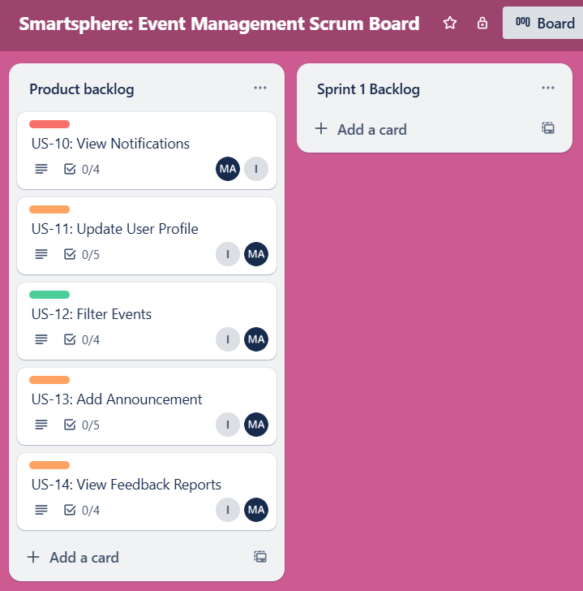

Snapshot of one of the above cards remaining in product backlog is attached for demonstration:  
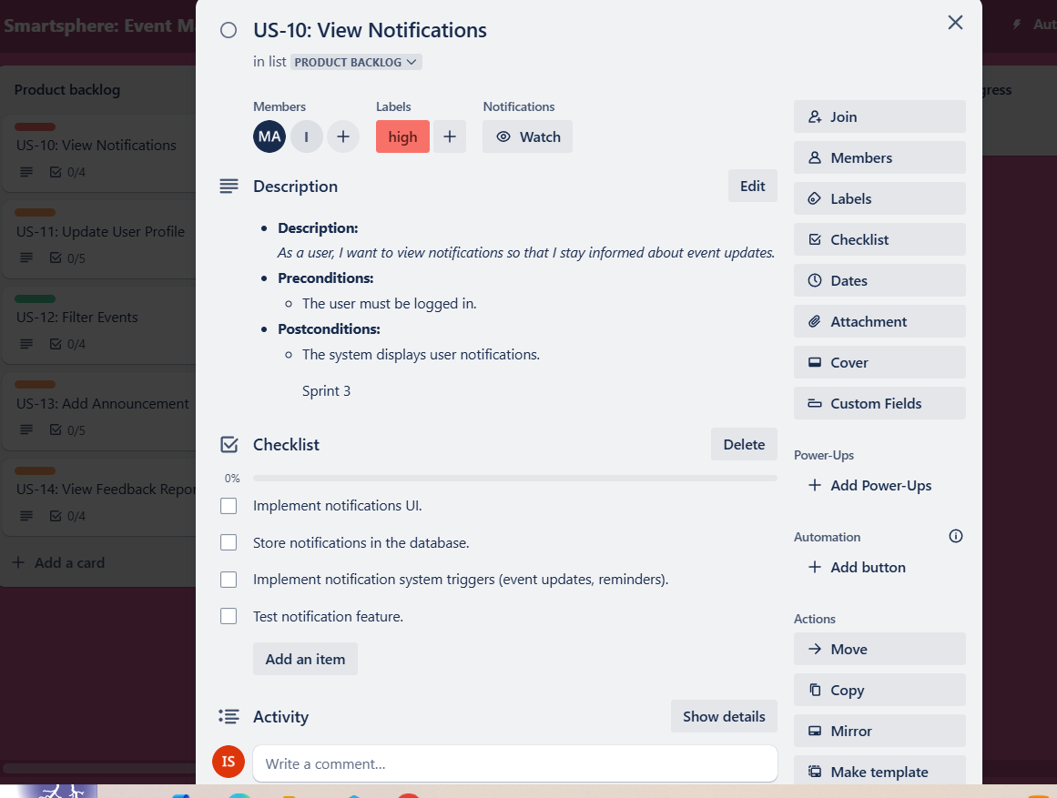

## Sprint 1:

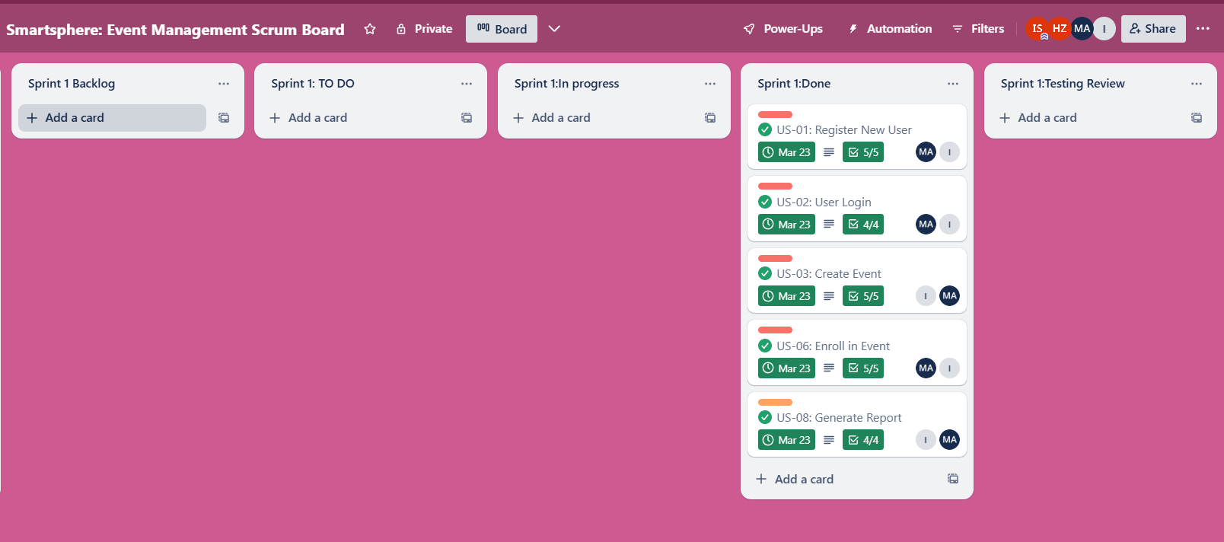

Snapshot of one of the above cards done in sprint 1 is attached for demonstration:  
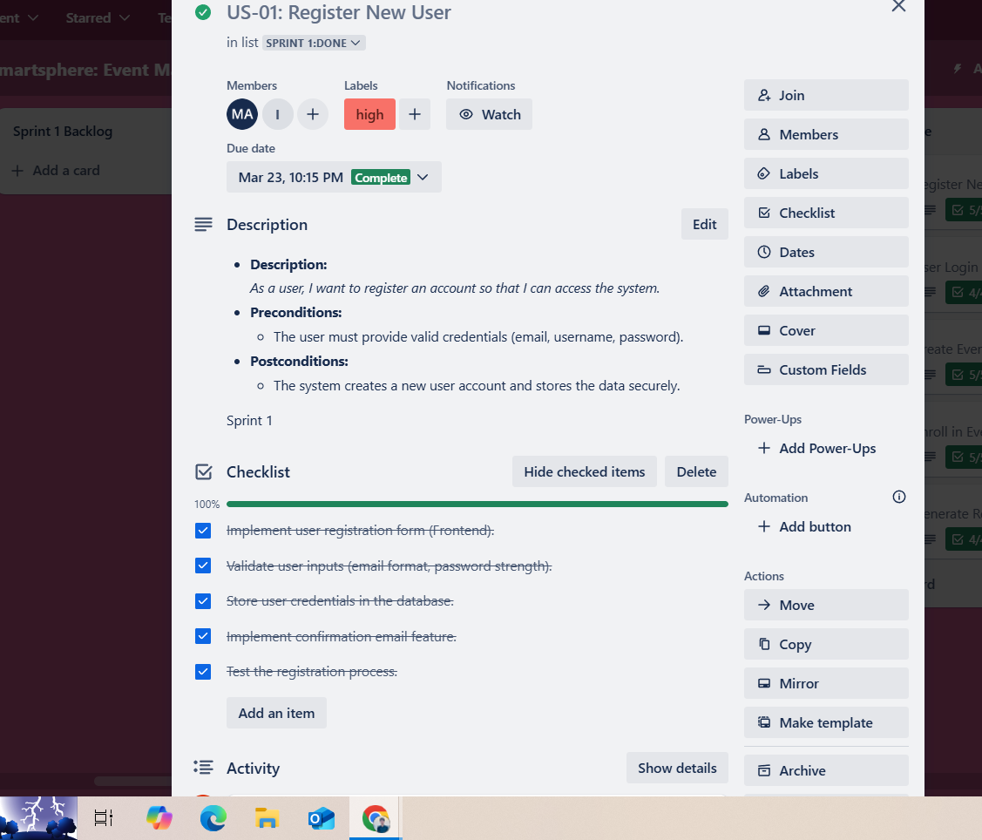

## Sprint 2:

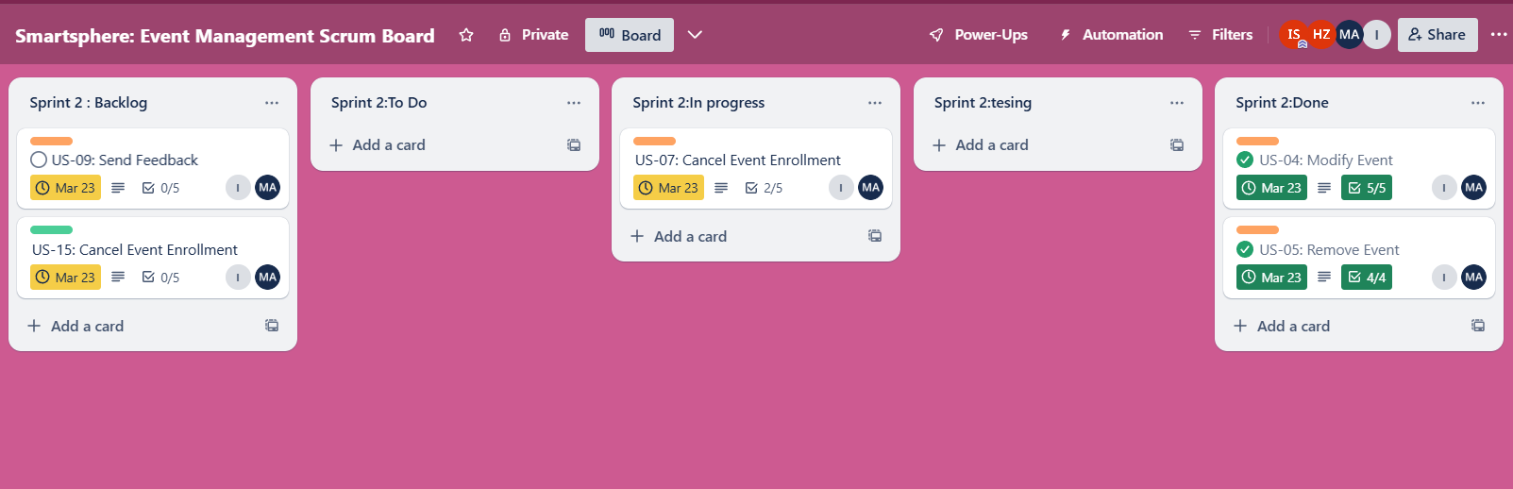

Snapshot of one of the above cards done in sprint 1 is attached for demonstration:

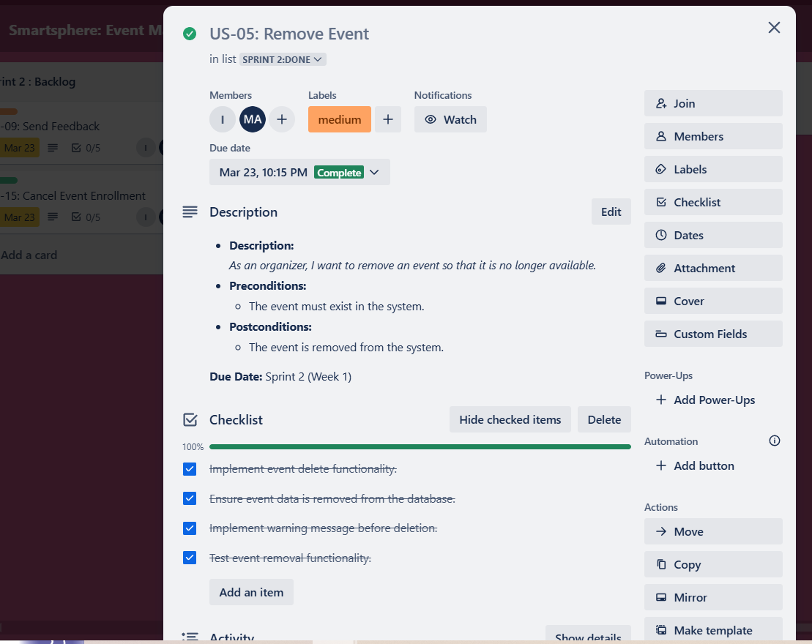

# 

# 

# 

# Part D-Github:

[github repository](https://github.com/Saifurrehman2094/Event-Manager.git)

